EX:NO:13 BPO MANAGEMENT SYSTEM

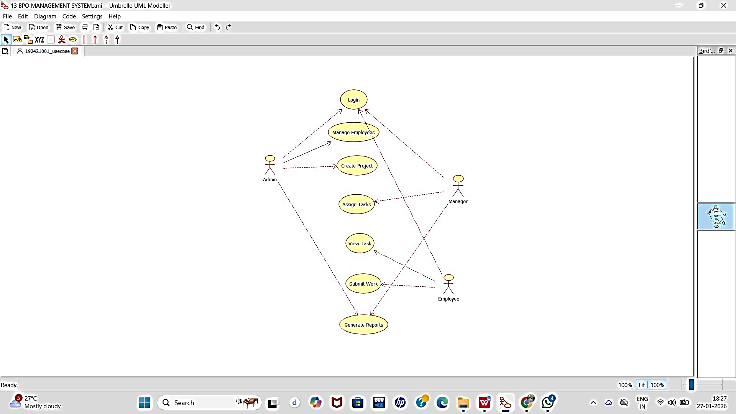
USECASE DIAGRAM:

CLASS DIAGRAM:

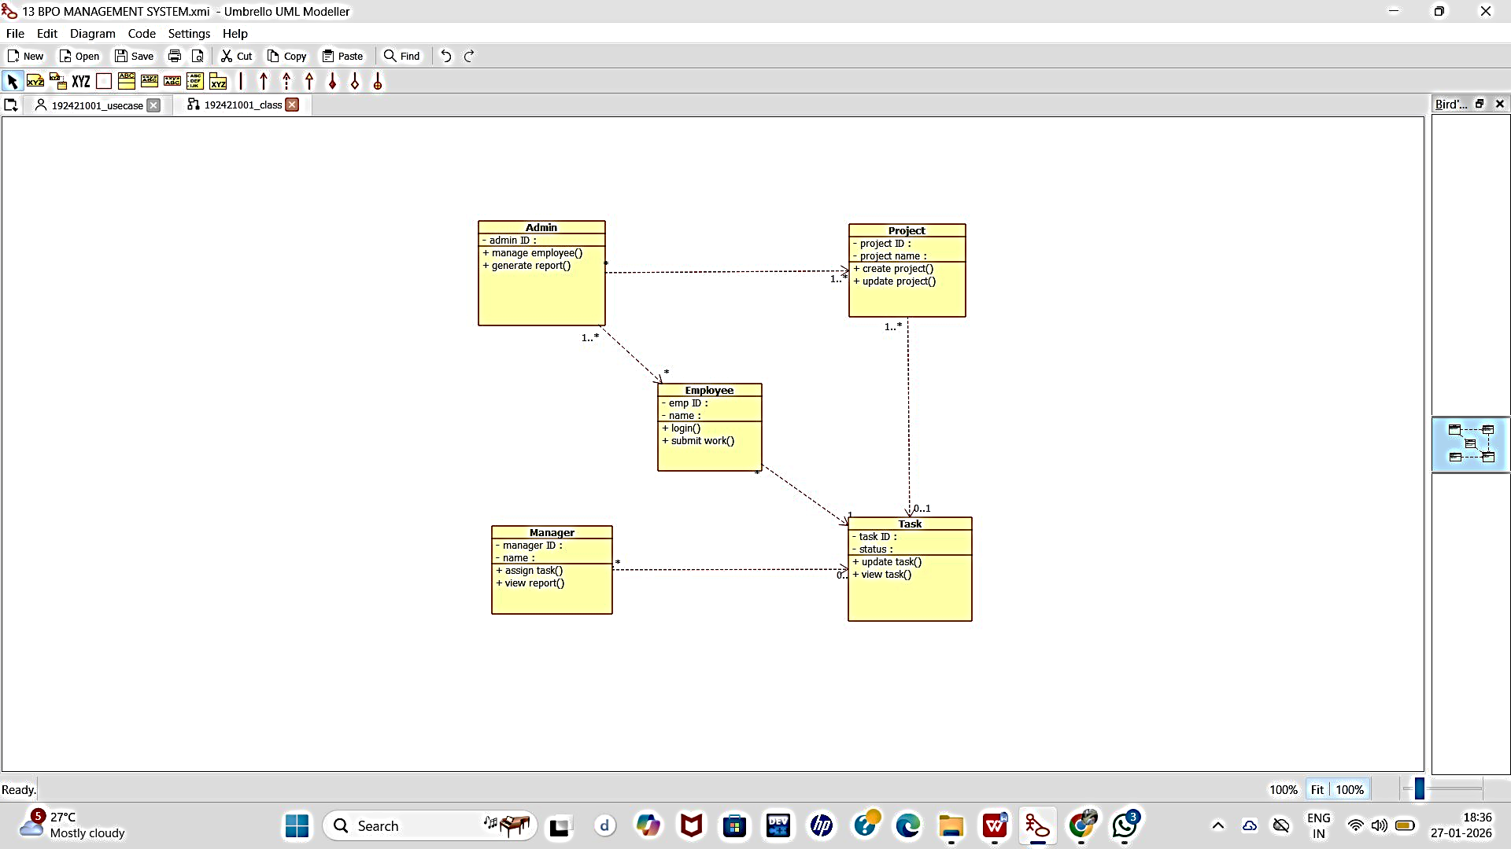

ACTIVITY DIAGRAM:
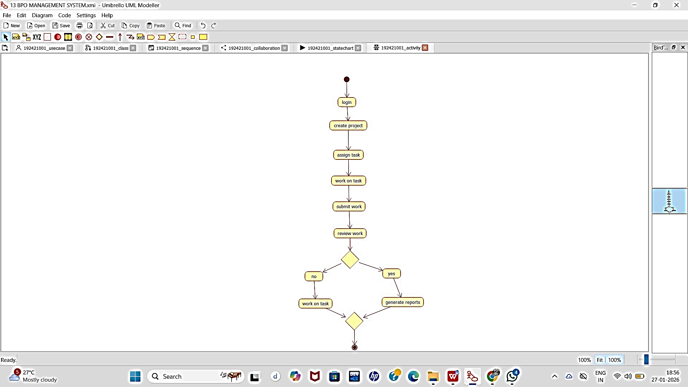

SEQUENCE DIAGRAM:

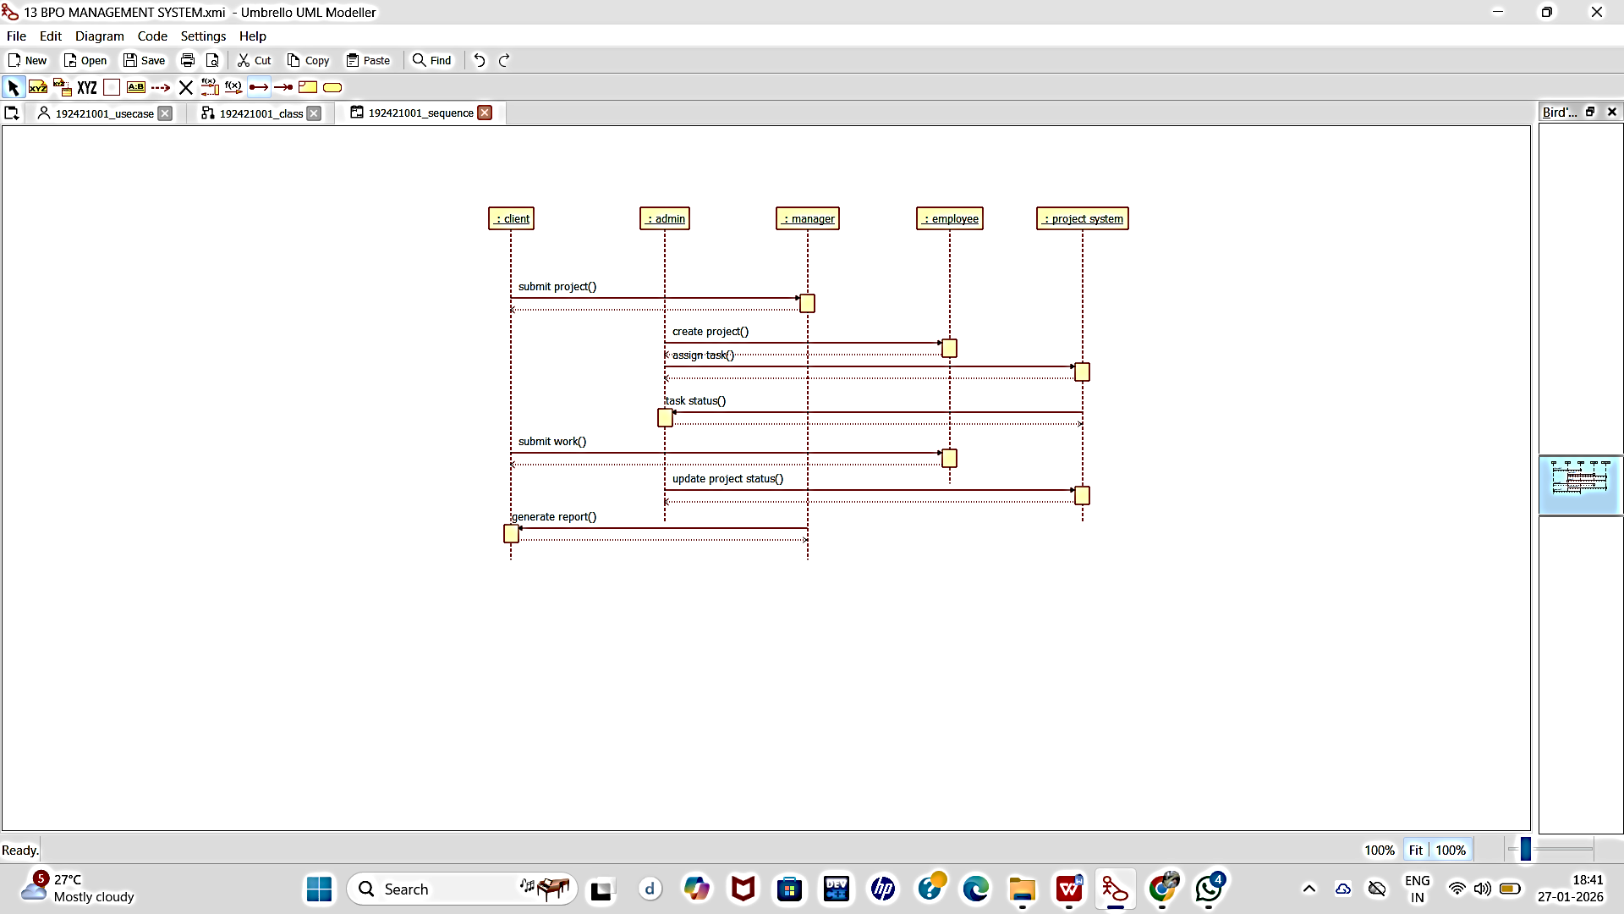

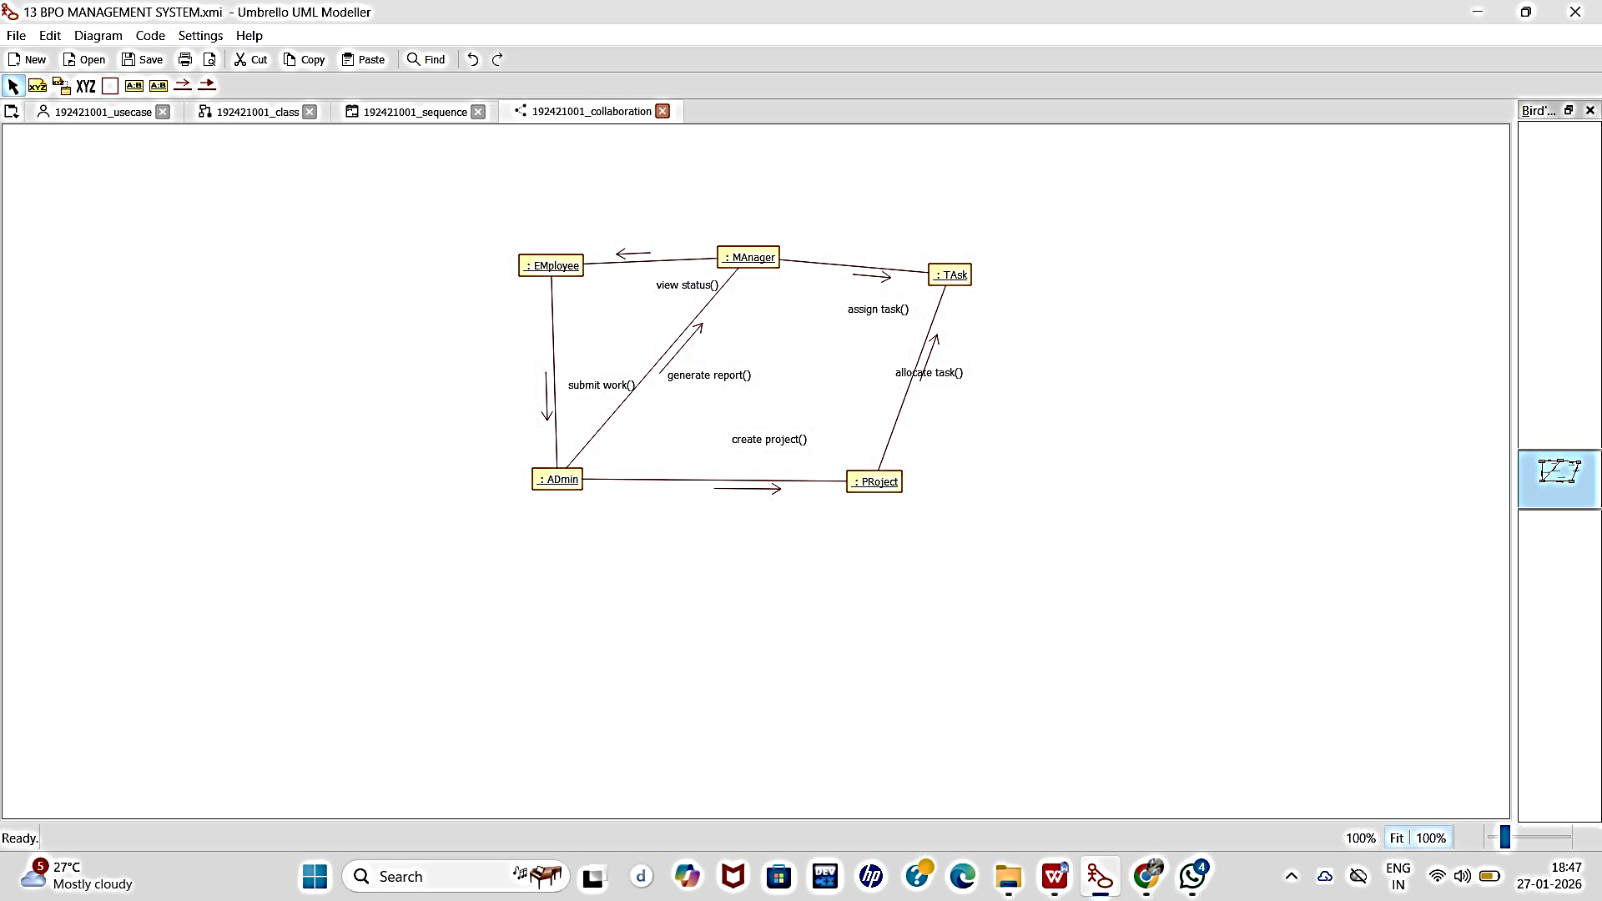
COLLABORATION DIAGRAM:

STATECHART DIAGRAM:

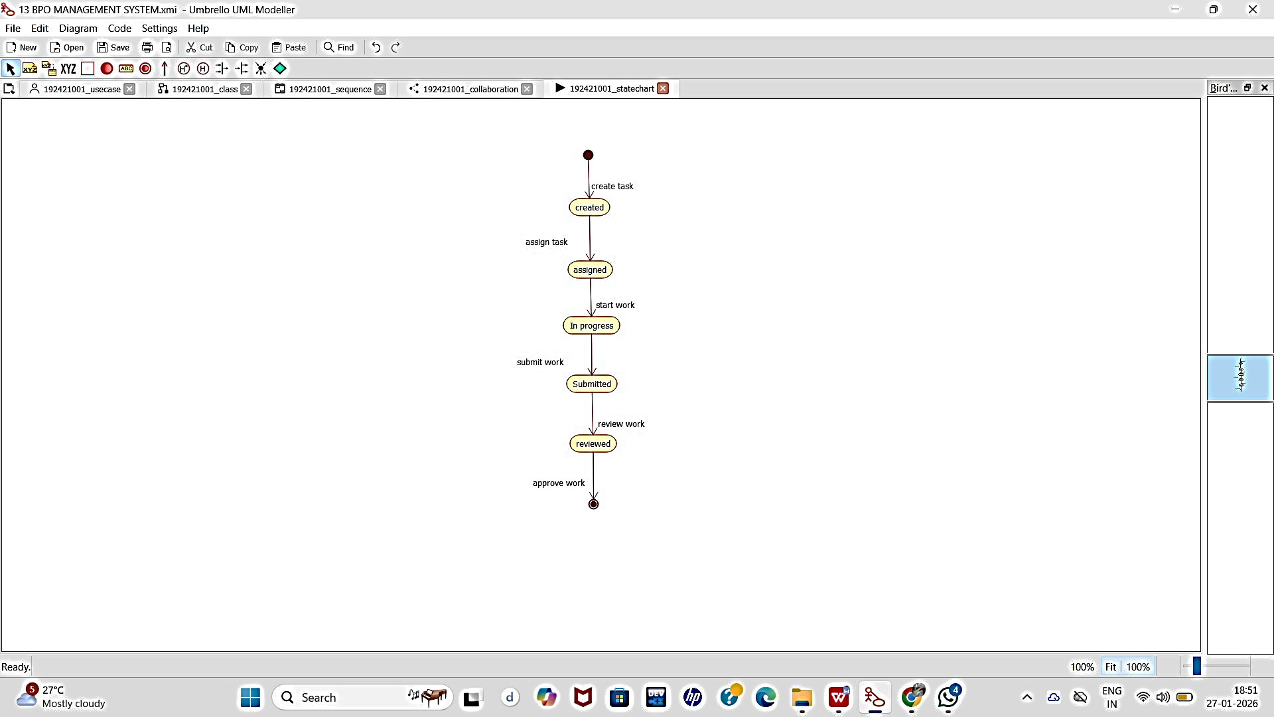

COMPONENT DIAGRAM:

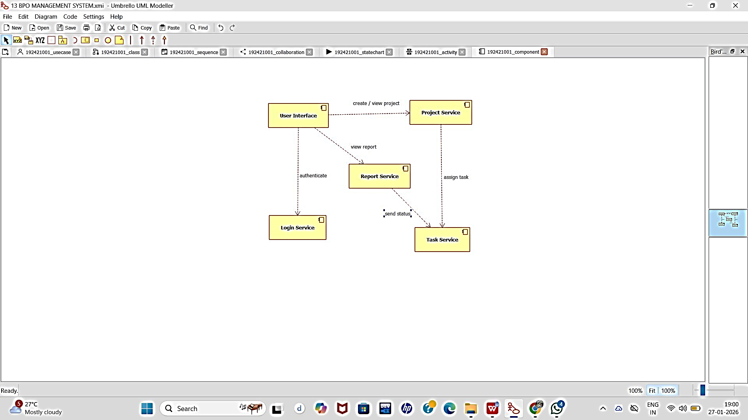

DEPLOYMENT DIAGRAM:

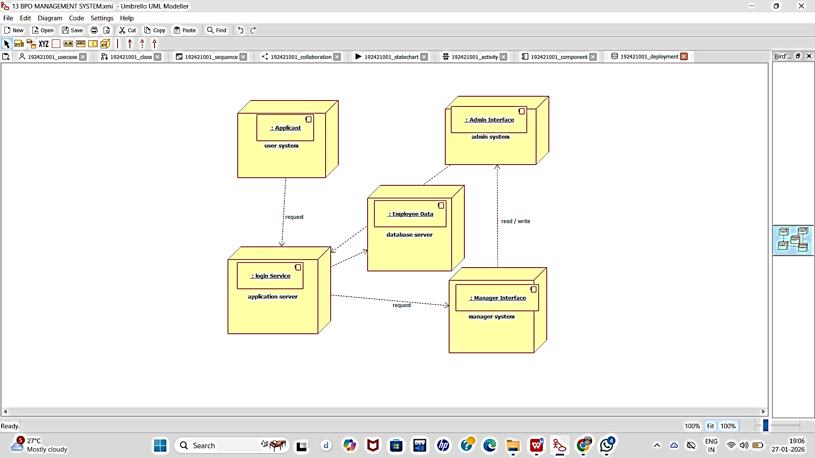

PACKAGE DIAGRAM:

